AWS Task-1
Task Description:
Create a windows Vm machine in AWS and connect with RDP open CMD in windows share the about system info.

Create Windows VM in AWS & Connect via RDP
Using:
- Amazon Web Services
- Amazon EC2
Step 1: Login to AWS
Logged into the AWS Management Console using valid credentials to access cloud services and resources.
Step 2: Launch Windows EC2 Instance
- Navigated to the EC2 dashboard and selected the Launch Instance option to create a new virtual machine.
- Configured the instance name and selected the Microsoft Windows Server AMI as the operating system.
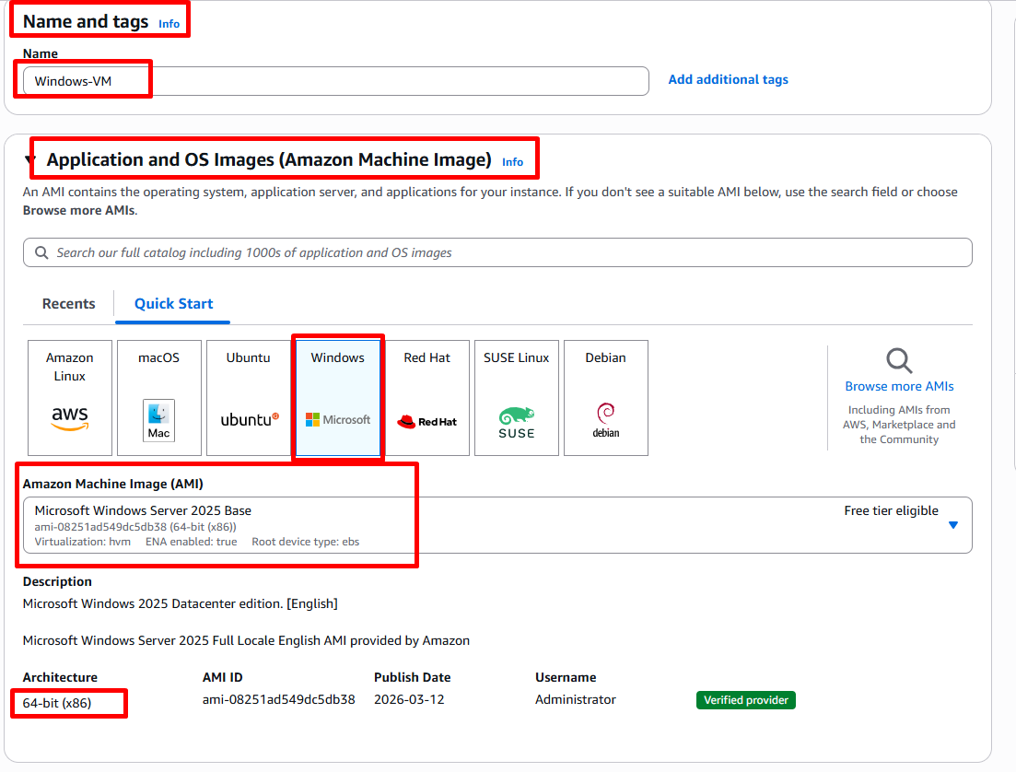
- Selected the instance type (t3.micro) under the free tier to deploy a cost-effective virtual machine.
- Created a new key pair for secure access to the instance and downloaded the .pem file.
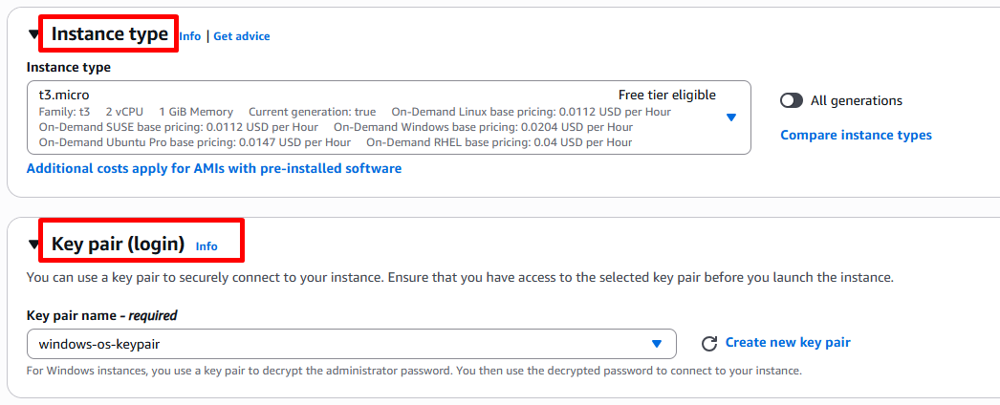
- Configured network settings and enabled RDP access (Port 3389) to allow remote connection to the Windows instance.
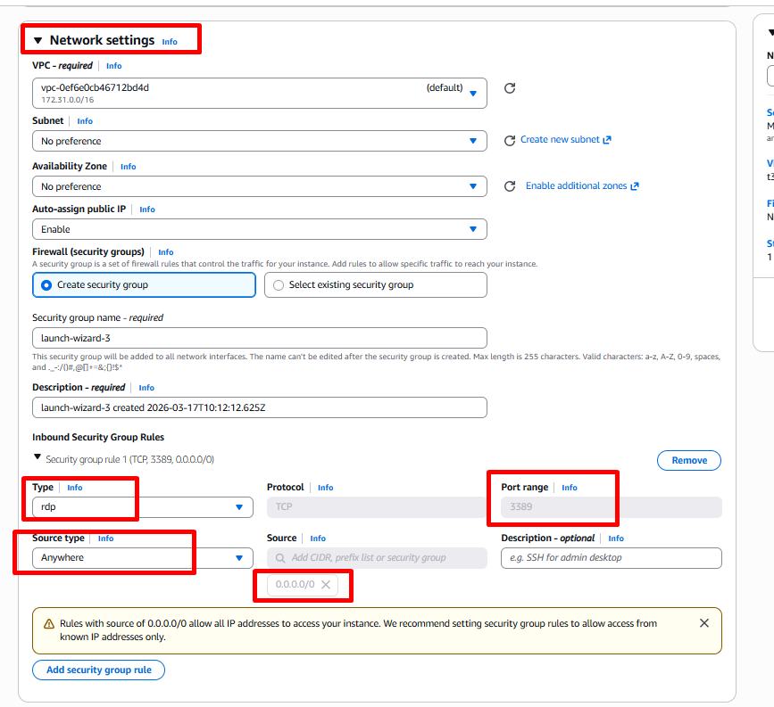
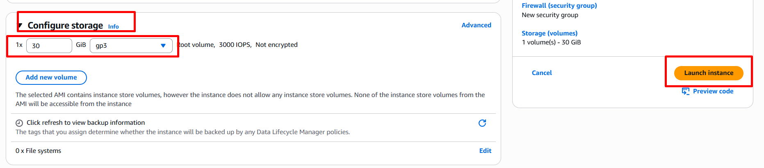
- Reviewed all instance configurations including storage and security settings before launching the instance.
- Successfully launched the Windows EC2 instance and verified that the instance state is running.
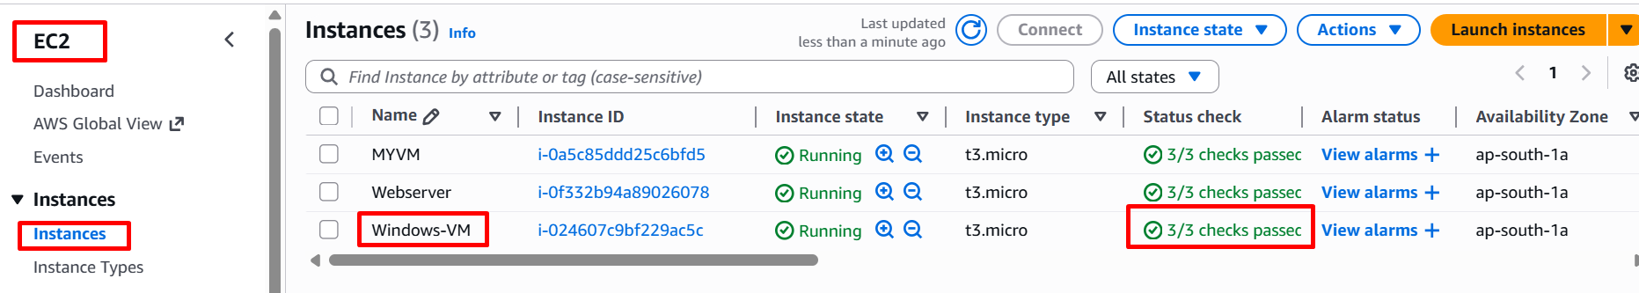

Step 3: Get Windows Password
Accessed the instance connection settings, retrieved the encrypted administrator password using the downloaded key pair, and prepared credentials for RDP login.
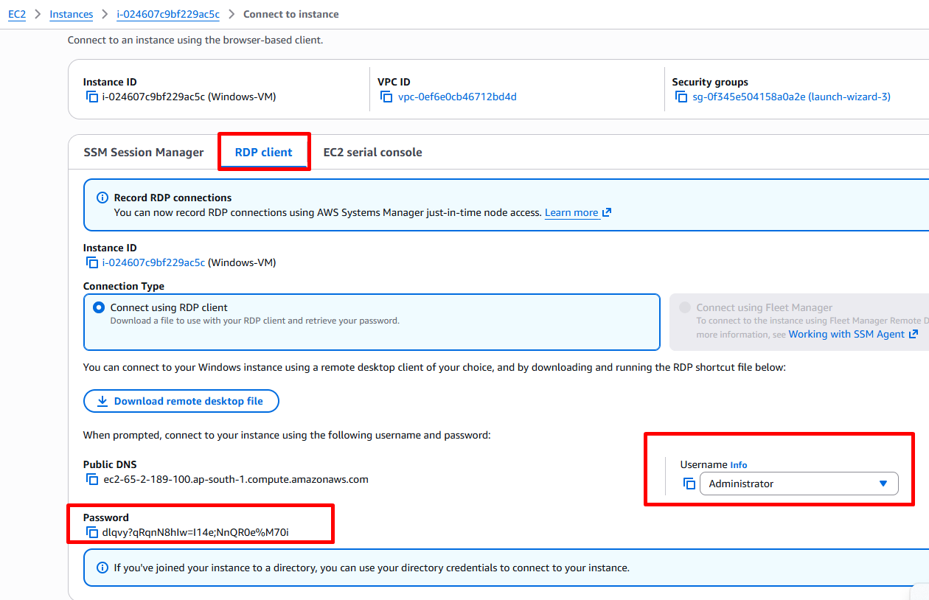
Step 4: Connect via RDP
Established a remote connection to the Windows EC2 instance using Remote Desktop Connection (mstsc) by entering the public IP address and administrator credentials.
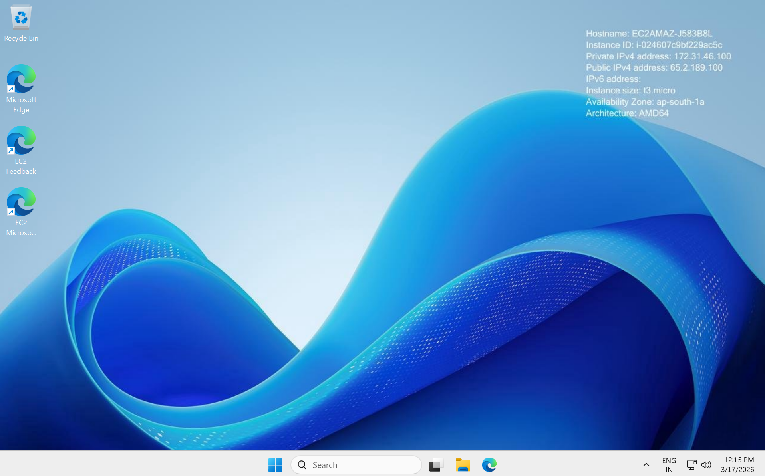
Step 5: Open Command Prompt (CMD)
Accessed the Windows virtual machine and opened the Command Prompt using the Run dialog (Win + R → cmd).
Step 6: Get System Information
Executed the systeminfo command in Command Prompt to retrieve detailed system configuration such as OS version, processor details, memory, and system type.
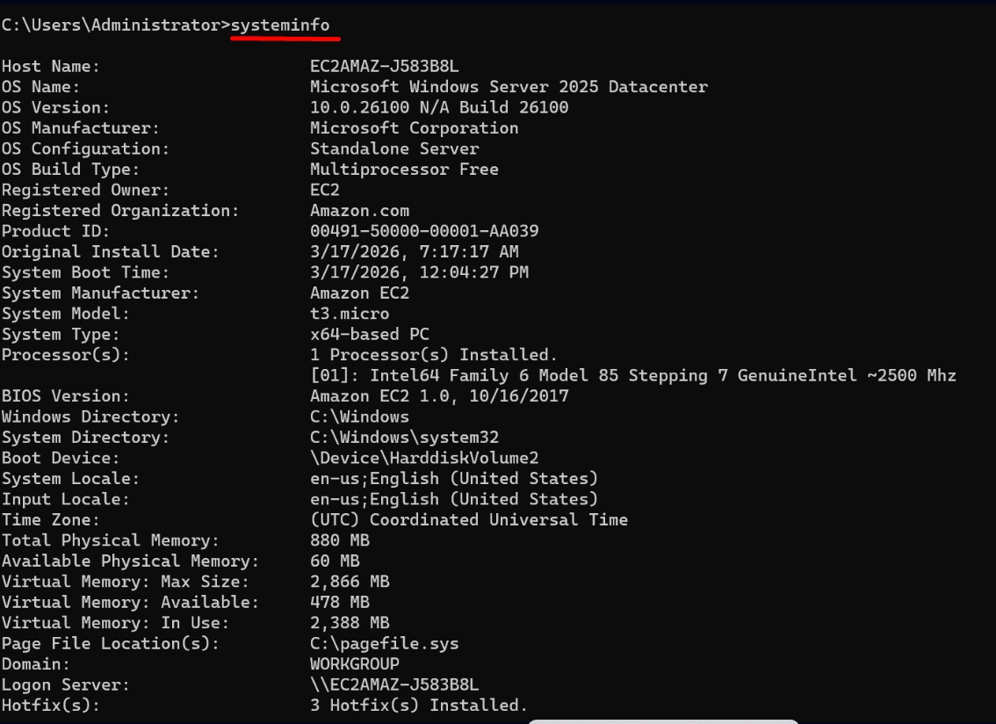
Successfully created a Windows virtual machine using Amazon EC2, connected via RDP, and verified system details using Command Prompt.

